|  |  |  |  |  |  |
| --- | --- | --- | --- | --- | --- |
| Date | 29-Nov-22 | | | Tester Name | Mayuri Patel |
| Environment | Penfax - Test | | | Login used |  |
| Operating System | Select OS | Version: | Update: | | |
| Software Used | Select Software | Version: | Update: | | |
| Select Software | Version: | Update: | | |
| Release version | 22.4.1 | | | | |
| Title |  | | | | |
| Test Type | Regression | | | | |
| Test Scenario | Process a VPB Setup | | | | |
|  |  | | | | |
| Expected Results |  | | | | |
| Pass/Fail | Pass | | | JIRA# | N/A |

Describe your steps with screenshots:

1. 100% Amount transfer in VPB

Find a member to set up for VPB

Open that member Profile

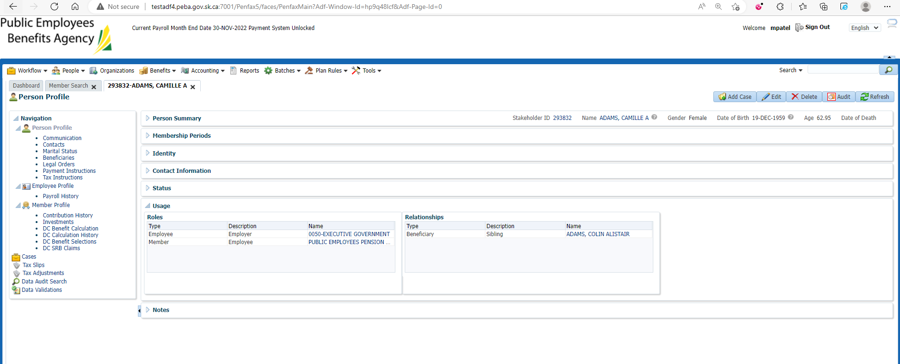

Go to DC Benefit Selection under member Profile

Add DC Benefit Selection

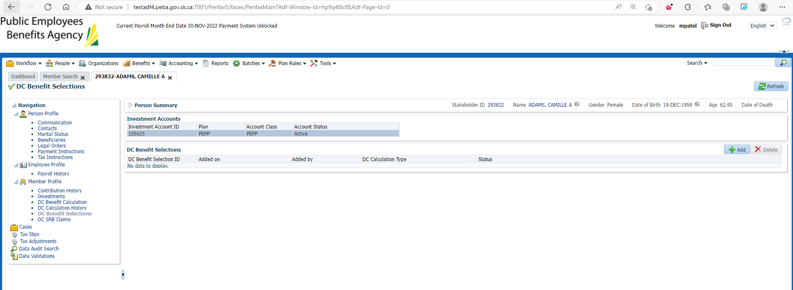

Enter Retirement Date and Next

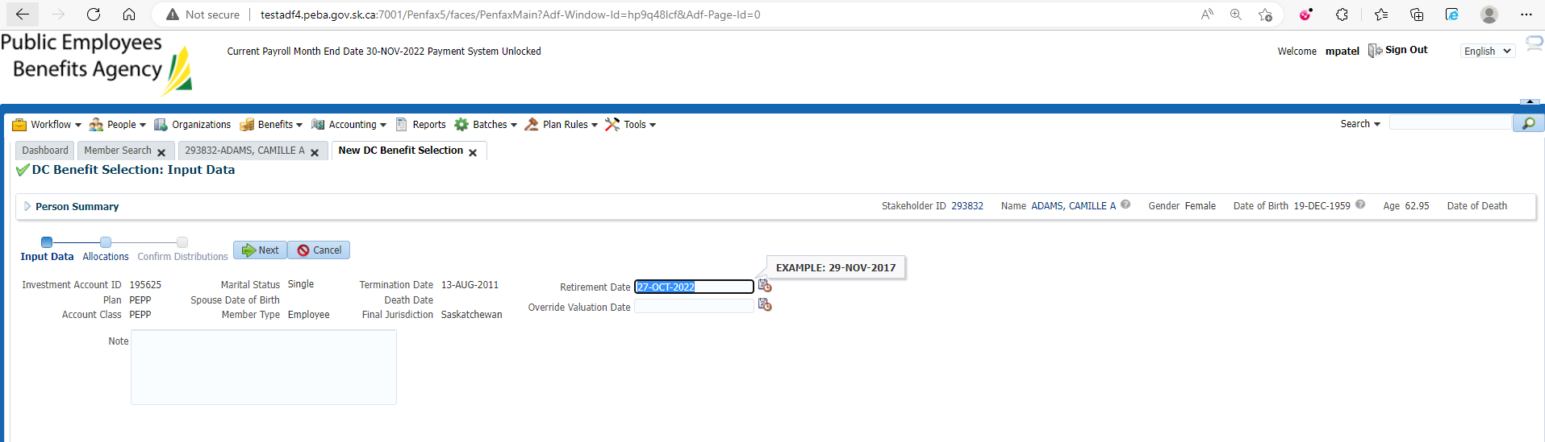

Allocate All funds to VPB Account

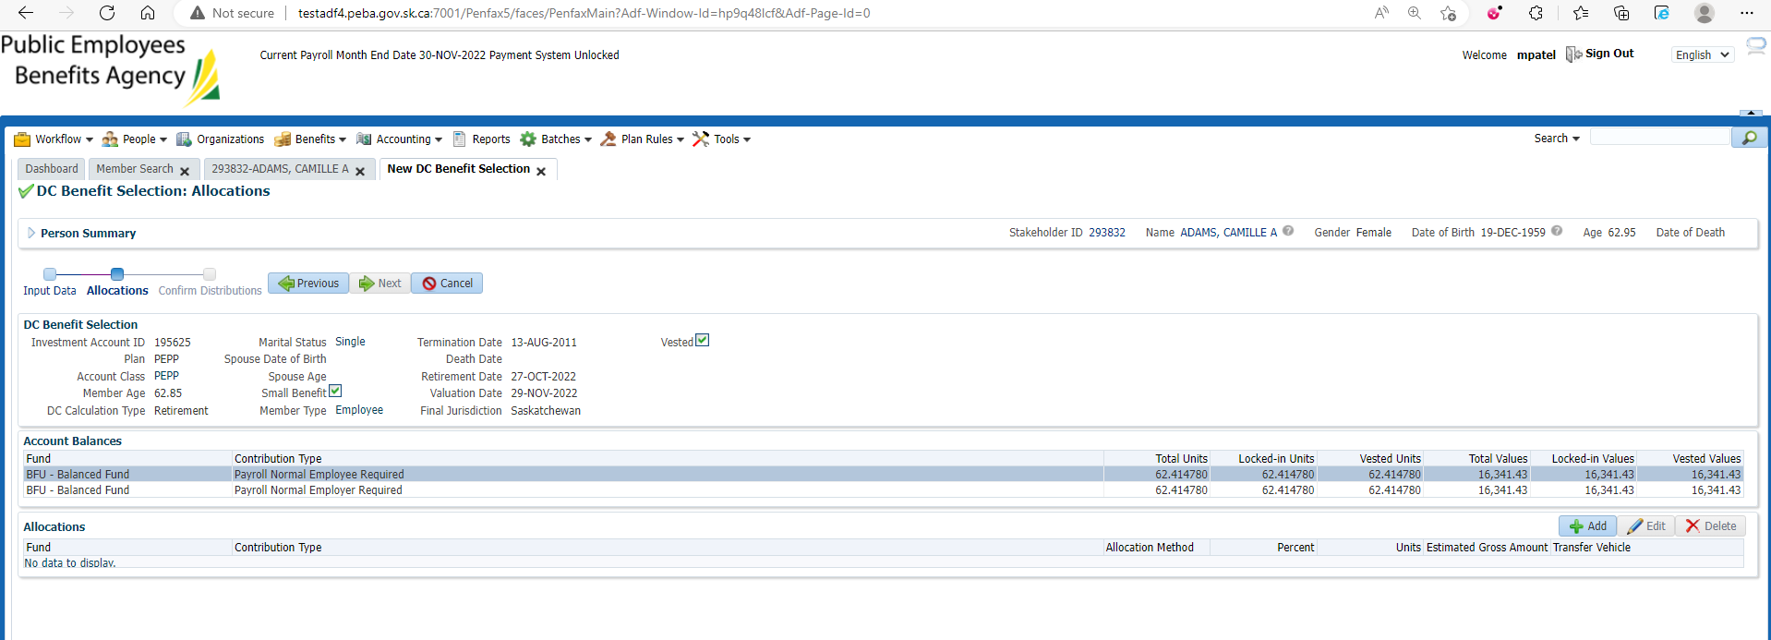

Next

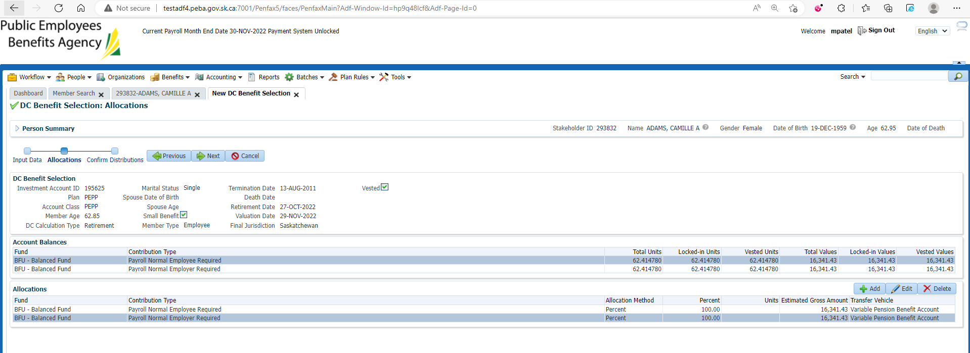

Submit it for Approval and approve it

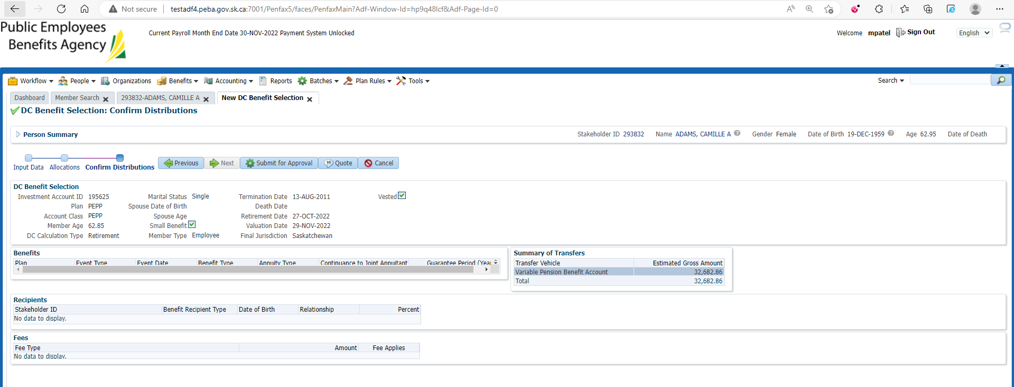

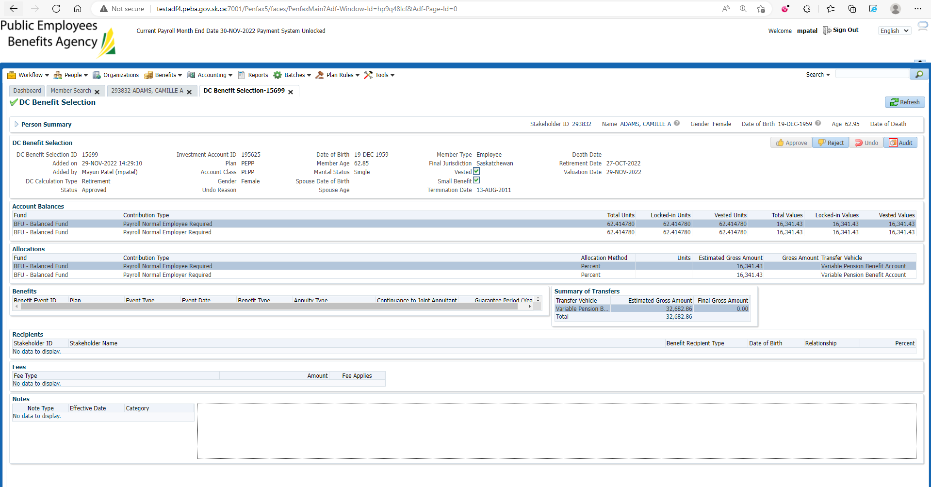

Check the investment account for VPB and PEPP

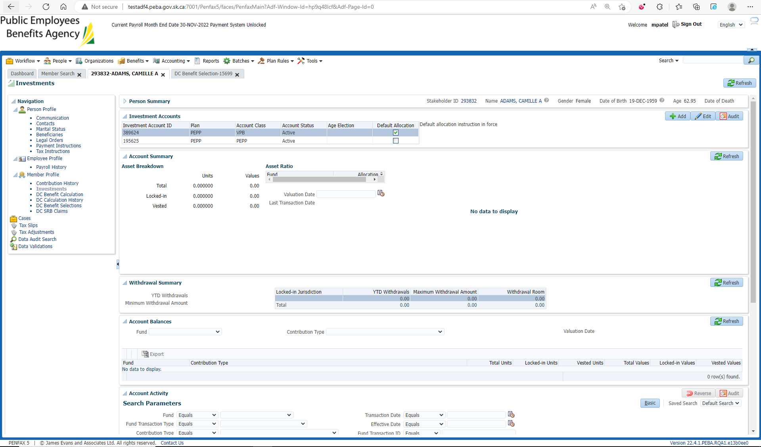

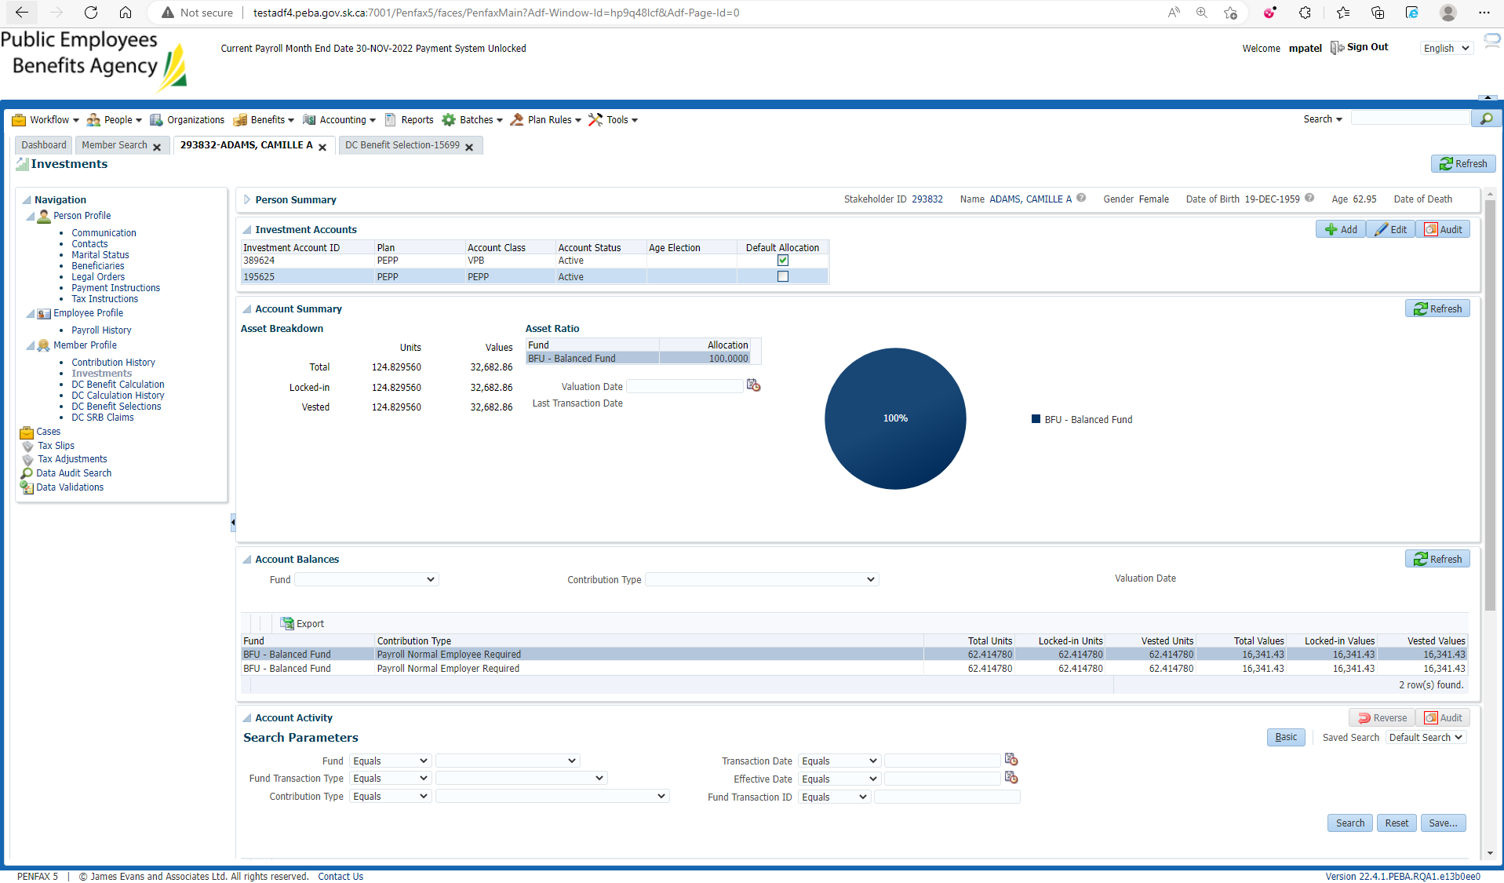

Set Scheduled Withdrawal Instruction for VPB

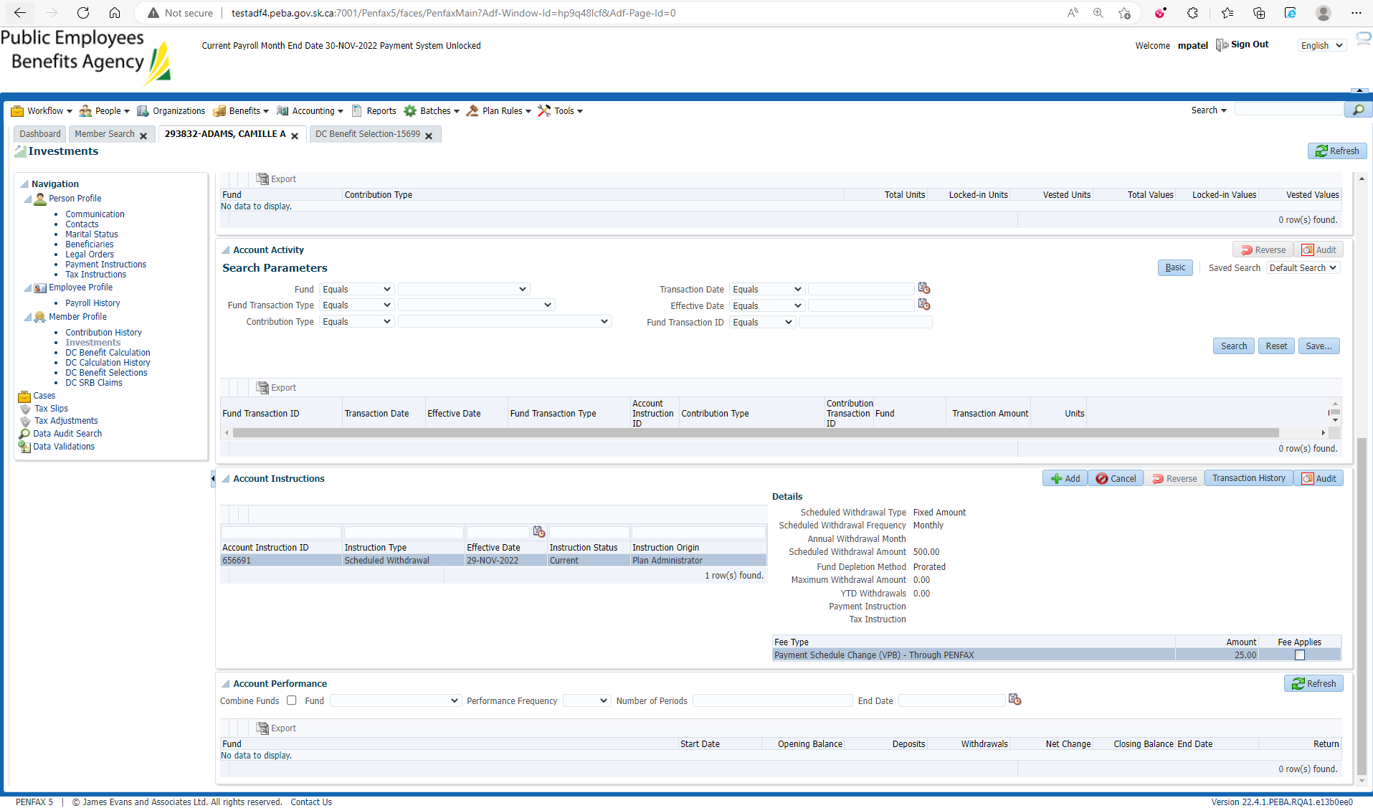

Set Tax Instruction for VPB

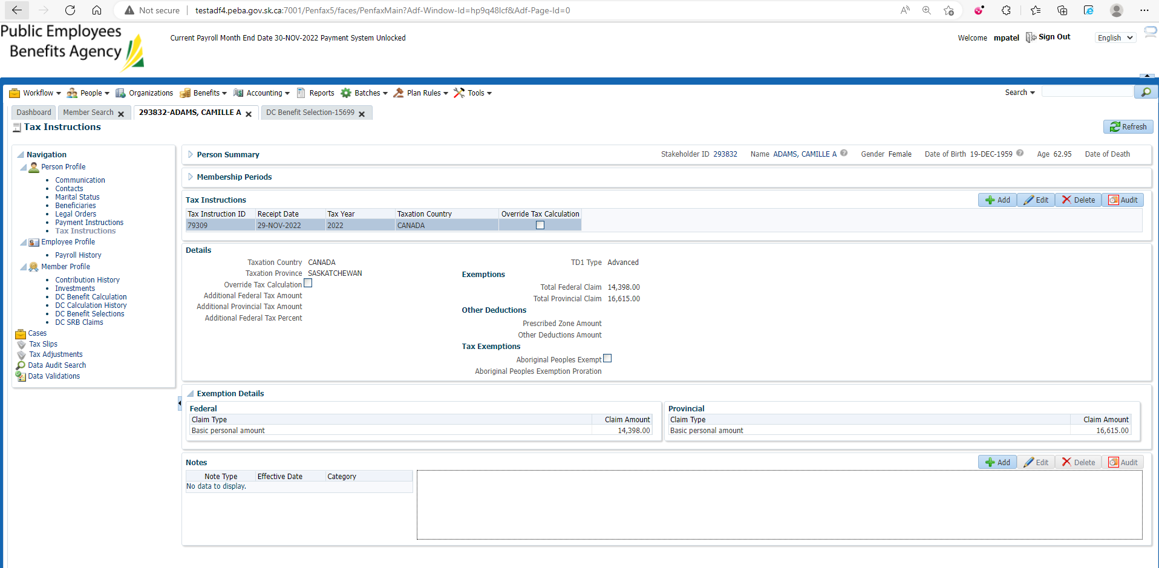

Set Payment Instruction for VPB

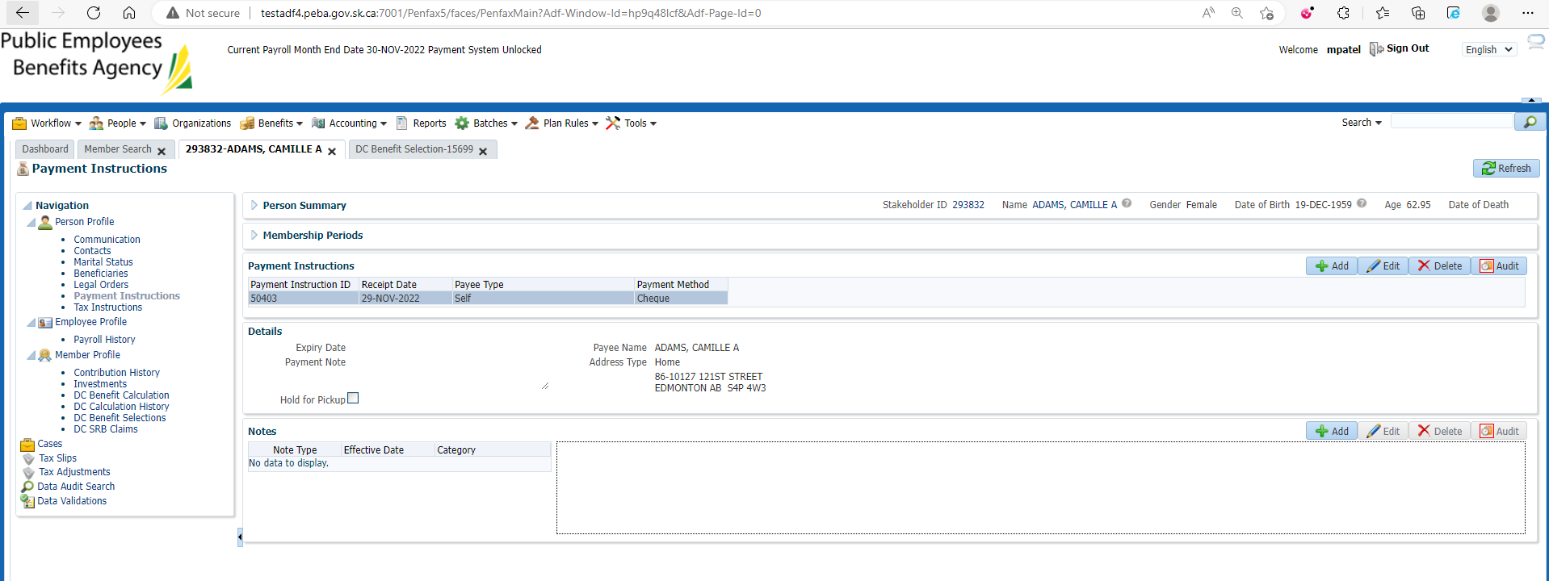

After Overnight PIT Batch

Make sure all the funds in PEPP is transferred to VPB Account

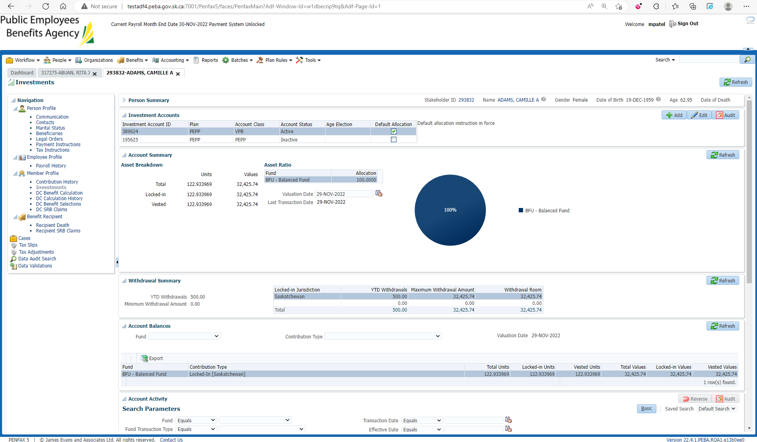

VPB account is active and PEPP is Inactive

